**Digikrom Spectrometer known work arounds**

Error -1073807343

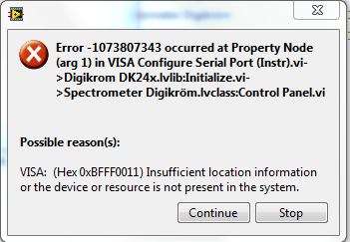

* Open up the Device Manager
  + Either search “Device Manager” in the start menu or open Control Panel -> Hardware and Sound -> Device Manager
* Right click on Ports -> Communications Port (COM1) and select Uninstall
* The computer will automatically restart
* Unplug and replug the spectrometer power supply while the computer is off

Novram read

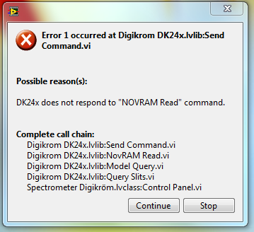

This error tends to occur most frequently when switching between gratings A and B. To minimize the effects, try to avoid switching back and forth.

* Restart the computer
* While the computer is off, restart the spectrometer by unplugging and replugging the spectrometer power supply

Any other errors:

* Taking all of the steps in Error -1073807343 usually fixes most errors
* When in doubt, turn stuff off and on again until it works